Improving Slack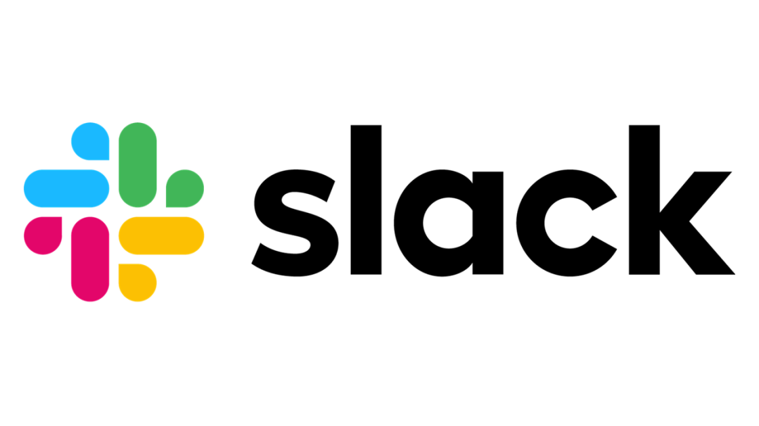
Slack leads to a false sense of work. It needs to be reimagined to be an-first communication tool at the workspace

Problems Identified

Information overload & distraction (insight- users feel overwhelmed by constant messages, @mentions, channel chatter, and integrations, making it hard to focus or find important updates)

Confusing navigation & cluttered UI (insight- Users complain that recent interface changes made Slack harder to navigate, with more clicks to reach common actions and poorer visibility into where conversations live )

Threads are not easy to track (insight- people say threads are hard to track, easy to miss, and the dedicated Threads view does not give a clear overview)
- Notifications are creating a lot of noise and leading to a 24/7 work feeling (insight- Commentators describe Slack as fostering a culture of immediacy, where people feel pressure to respond instantly, harming focus and work–life boundaries)
- Huddles are described as unstable, with recurring audio issues and reliability problems (insight- Huddles are described as unstable, with recurring audio issues and reliability problems that make them less trustworthy for important calls)

Solutions

Information overload

- Create a default Home view that shows a prioritized feed: followed threads, direct mentions, decisions, and action items summarized by Slack AI, rather than a chronological list of every channel.​ (Logic: Mimics Teams’ “followed threads” and Zoom’s AI Companion recaps, so users land where signal is highest, not where raw volume is highest, reducing the cognitive load after any time away)
- Make AI recaps the default when returning to a busy channel or after long absences, with “Show summary of what I missed” shown prominently before any scroll (Users rarely need every message; they need decisions, blockers, and mentions, which Slack AI already identifies through thread summarization and recaps)

Confusing navigation & cluttered UI

- Let users choose between a “Workspace-centric” layout (current Slack), a “Teams-like” layout (tabs for Activity, Messages, Channels, Files), and a “Discord-like” layout (servers/workspaces in a left rail, channels in the next) (Logic: Different mental models suit different orgs; competitors each pick one, but Slack can differentiate by letting users pick the model that best matches how they think about work)
- Use AI to power a command palette where users can type intent (“jump to marketing launch thread,” “find last decision on pricing”) and be taken directly to the relevant thread or recap. (Logic: Teams and Copilot demonstrate demand for intent-based navigation; translating messy mental queries into the right channel or message bypasses UI complexity.)
- Offer an “Essential mode” that hides advanced features (Canvases, complex apps, custom workflows) and reduces UI clutter, while “Power mode” exposes everything (Logic: Critics call Slack “bloated”; giving new or non-technical users a pared-down experience avoids overwhelming them while preserving depth for advanced users)

Threads are not easy to track

- Let users explicitly “follow” a thread so it appears in a dedicated “Followed Threads” view, mirroring Teams’ approach, and allow unfollowing to stop updates without muting the whole channel. (Logic: A small number of important threads typically matter most; a focused view gives a clear overview and reduces the feeling of “threads disappearing into the void)
- Default behavior: only notify when someone @mentions you or reacts to your message in a thread, with opt-in “notify for all replies” for critical cases (Logic: Today’s default feels noisy and random; aligning with how people mentally prioritize conversations keeps threads relevant without becoming notification spam)

Notifications are creating a lot of noise and leading to a 24/7 work feeling

- Let users set work windows (e.g., 10:00–17:00) that become the default for notifications; messages outside those windows are batched into scheduled digests unless explicitly marked “urgent.” (Logic: Teams links notifications to calendar and quiet hours; Slack can do similarly, reinforcing a norm that most messages can wait and reducing personal pressure to respond instantly)
- Encourage senders to label messages; only “urgent” can bypass DND by default, while “FYI” is digest-only and doesn’t trigger push notifications, compatible with existing @-mention flows (Logic: Noise is partly a sender problem; teaching people to categorize importance makes the system’s behavior predictable and allows recipients to manage attention without losing critical alerts)
- Give admins tools to set workspace-wide norms: default DND hours, maximum allowed notification bypasses per day, and prompts that appear if someone is pinging colleagues outside working hours. (Logic: Individual settings are not enough; team culture determines expectations, so Slack should give companies levers to encode healthier norms into the product itself.)

Unstable, unreliable Huddles
- For orgs already using Zoom or Teams, provide a first-class “Start Huddle (Zoom)”/“Start Huddle (Teams)” button that launches the call in the preferred provider while keeping Slack for messaging. (Logic: Zoom and Teams are perceived as more reliable; letting Slack lean on their infrastructure where appropriate acknowledges reality and improves trust for important calls.)
- Split Huddles into “Quick Huddle” (low-latency, audio-first, minimal features) and “Meeting Huddle” (richer video, recording, screen share), each using different back-end settings tuned for reliability vs capability (Logic: Many reliability issues stem from trying to do everything with one stack; separating use cases makes it easier to optimize and communicate trade-offs to users)
- Add built-in recording and automatic AI-generated notes and action items for Meeting Huddles, stored directly in Slack with links posted back to the relevant channel. (Logic: Competitors already lean on AI meeting summaries; making this a core, reliable feature increases the perceived value of Huddles and reduces the fear that a flaky call will also lose important information)

What makes this version better?
- Information overload, confusing navigation, and noisy notifications are tightly coupled, so Slack should treat “Attention Management” as a unified product area with AI, UI, and policy-level features working together.​
- Threads and Huddles can serve as the backbone of decision-making if they are reliable, easy to find, and summarized, transforming Slack from a stream of chatter into a structured system of work

Prototype Link-https://app-a0bad0b3-ba89-4121-a1db-c68d3dfdcffe.base44.app/

